Expense Tracker DB SQL Project
1. Create Database
CREATE DATABASE ExpenseTracker;
USE ExpenseTracker;
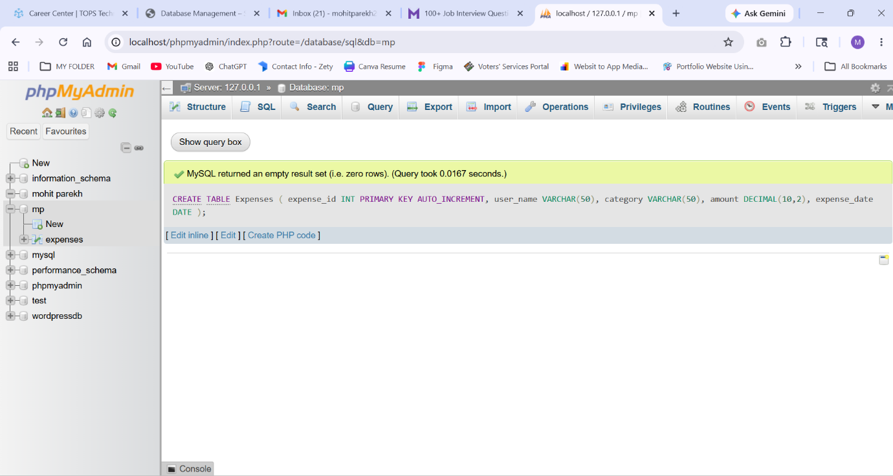

2. Create Table
CREATE TABLE Expenses (
expense_id INT PRIMARY KEY AUTO_INCREMENT,
user_name VARCHAR(50),
category VARCHAR(50),
amount DECIMAL(10,2),
expense_date DATE
);
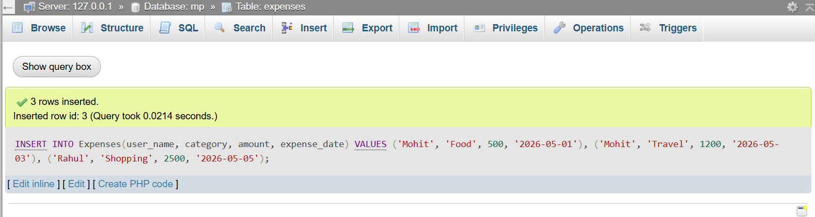

3. INSERT (Create)
INSERT INTO Expenses(user_name, category, amount, expense_date)
VALUES
('Mohit', 'Food', 500, '2026-05-01'),
('Mohit', 'Travel', 1200, '2026-05-03'),
('Rahul', 'Shopping', 2500, '2026-05-05');
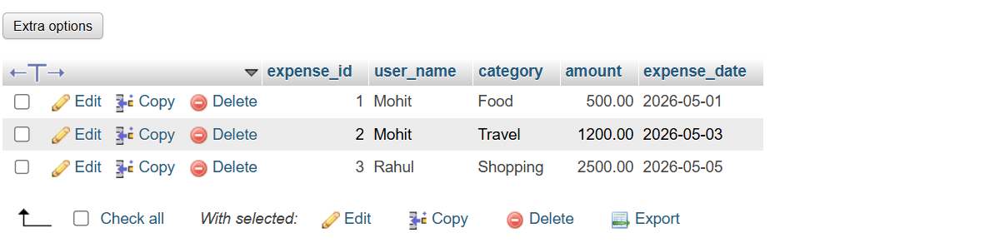

4. SELECT (Read)
View All Expenses
SELECT * FROM Expenses;
View Expenses of Mohit
SELECT * FROM Expenses
WHERE user_name = 'Mohit';
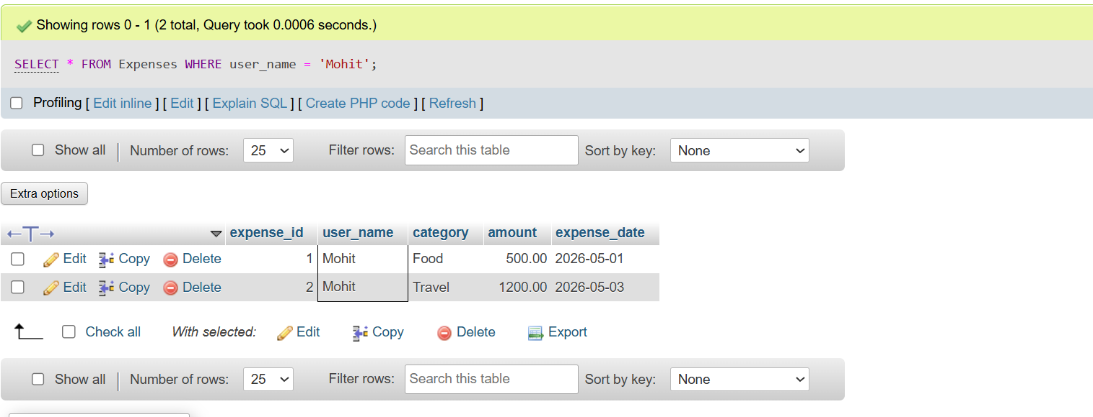

5. UPDATE
UPDATE Expenses
SET amount = 1500
WHERE expense_id = 2;
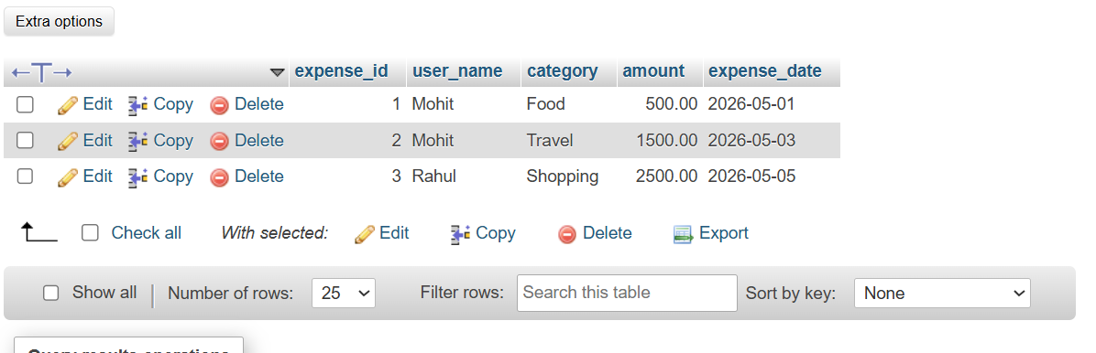

6. DELETE
DELETE FROM Expenses
WHERE expense_id = 3;
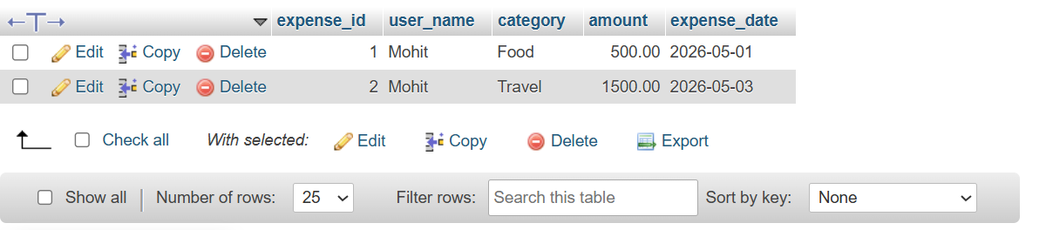

7. Stored Procedure
Calculate Monthly Expense of User
DELIMITER //

CREATE PROCEDURE MonthlyExpense(
IN u_name VARCHAR(50),
IN month_num INT
)
BEGIN
SELECT
user_name,
MONTH(expense_date) AS Month,
SUM(amount) AS Total_Expense
FROM Expenses
WHERE user_name = u_name
AND MONTH(expense_date) = month_num
GROUP BY user_name, MONTH(expense_date);
END //

DELIMITER ;
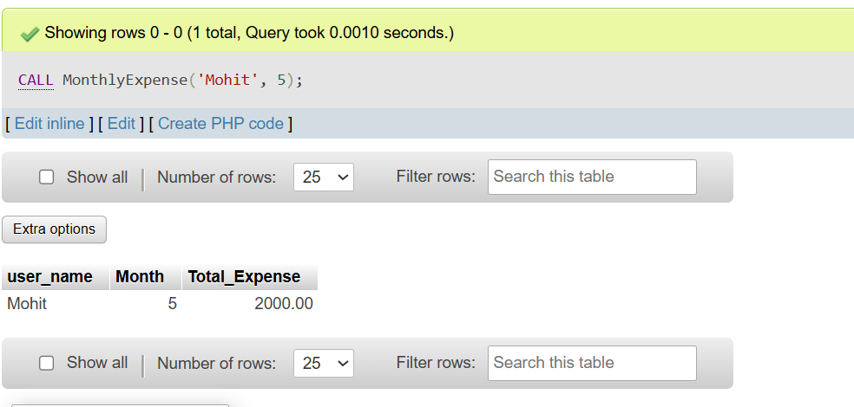

Execute Stored Procedure
CALL MonthlyExpense('Mohit', 5);

8. COMMIT Example
START TRANSACTION;

INSERT INTO Expenses(user_name, category, amount, expense_date)
VALUES ('Mohit', 'Bills', 3000, '2026-05-10');

COMMIT;
Result:
Data is permanently saved.
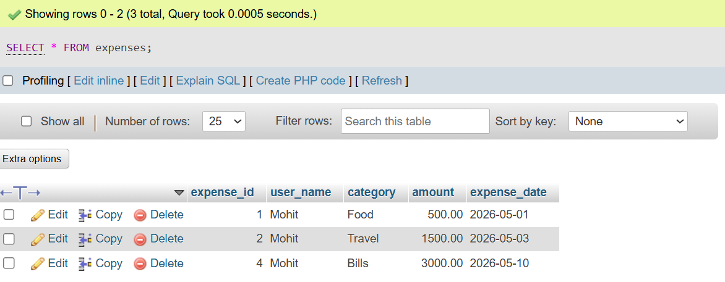

9. ROLLBACK Example
START TRANSACTION;

INSERT INTO Expenses(user_name, category, amount, expense_date)
VALUES ('Rahul', 'Movies', 800, '2026-05-12');

ROLLBACK;
Result:
Inserted data is cancelled and not saved.
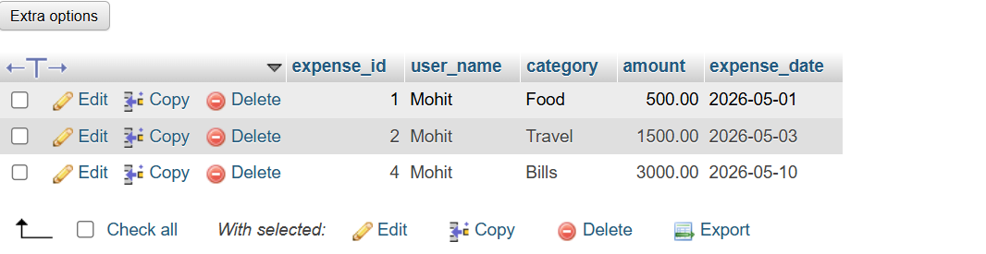

10. Final Table View
SELECT * FROM Expenses;


